1. **Full Name and Address of the inventor(s) and applicant(s) (if different).**

Parth Bhalerao (ECE Final Year)

Huzefa Essaji (ECE Final Year)

Vivek Kaushik (ECE Final Year)

Aditya Pathak (IT Final Year)

Chandrakant Mohadikar (ECE Final Year)

Anuj Sharma (Industry Project Guide)

Rahul Laddhad (Industry Project Guide)

Dr. Mridula Korde (Department Faculty & Project Guide)

1. **What is the suggested title of the invention?**

Title of the topic is : Point of care device for measurement and analysis of vital parameters

1. **The** **relevant prior art/existing technology and its disadvantages**

An ECG is considered the best method for detecting heart abnormalities. The available ECGs vary from single to 12-lead ECG recording devices. On one hand, hospital ECG acquisition devices are usually big in size and support high-precision and long-term monitoring. However, they restrain the patients’ movements and involvement.

On the other hand, wearable health-monitoring systems afford real-time continuous monitoring of patients’ through the deployment of multiple sensors , but are not accurate.

Also, to measure different vital parameters, different devices are required and their doesn’t exist a common device, which measures and does analysis of all the vital parameters.

Even if, one wishes to develop so, currently no such technology or device is present in low form factor which is easy to operate and portable to carry.

1. **What are the objectives/advantages of your invention?**

Following are the objectives of our invention or product :

* To develop a device which is highly portable to measure all the vital parameters like :
* ECG
* Heart Rate
* SpO2
* PPG
* Blood Pressure
* To provide visuals of skin, eye pupil, ear canal & throat passage, using a camera.
* Following are the advantages of our invention :
* Low Form Factor
* Highly Portable
* Affordable cost
* High Accuracy
* Connected to Android Application & Web Interface
* Measures all vital parameters in a single device

1. **Problems Solved by the invention:**

As we know, whenever patient goes to a doctor, with some slightly irregular symptoms, the most common advice that is given to him is to get performed with all vital related tests like ECG, PPG, SpO2, etc.

A recent survey conducted shows that in year 2019, almost 18 million people died due to cardio vascular diseases and in most of these cases, either the disease was diagnosed late or was not even diagnosed till the patient’s death. This is the survey which was conducted before covid-19 pandemic, however the numbers have seriously increased after pandemic.

In a country like India, many people travel from rural areas to urban area to visit various multi-speciality hospitals but cannot afford these tests and if they visit local clinics, they many a times do not have these facilities.

To provide a solution to this problem, we have come up with a highly portable device, which provides highly accurate results.

1. **Complete description of the invention supporting with line diagrams. The description should include all the elements of the invention their construction with respect to other elements and function thereof.**
2. **Block diagram and Functional description**

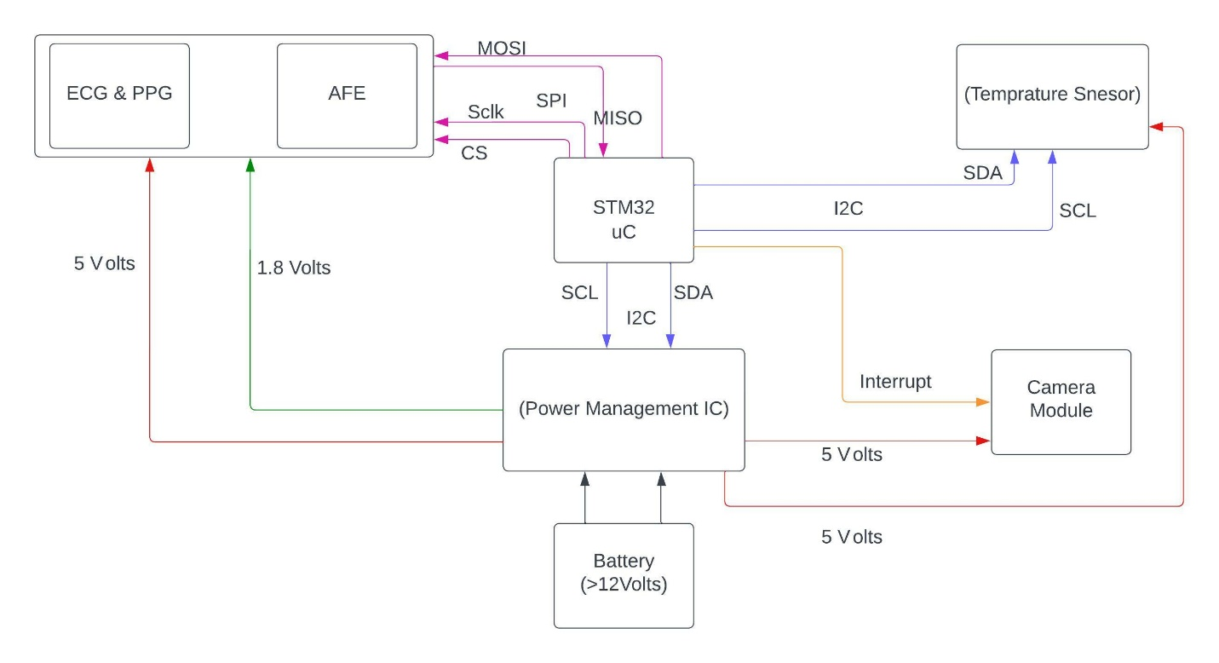

* A 12 volt battery is connected to power management IC which performs task of supplying appropriate voltage to several components of system.
* Temperature sensor is used to perform basic task of measuring body temperature.
* ECG & PPG sensor is used to collect relevant data , which is used further to calculate several parameters like SpO2, Heart Rate, etc.
* Camera Module is used to take clear pictures of several body parts like, pharynx (throat passage), ear canal , skin , eye & pupil.
* STM32 is the microcontroller used and is responsible for communicating with all the sensors and camera module. Also, it is responsible for collecting several data and communicating via Bluetooth and sending data to web platform and performing edge computing.
* All the relevant data after computation, can be sent to web platform or android application, via which a practo-service can be established and patients can remotely connect with doctors.

1. **Circuit diagram and its description**

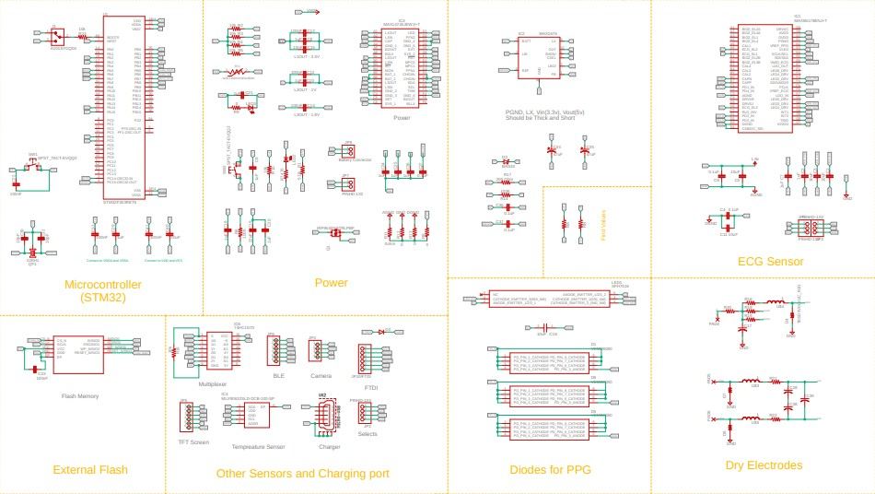

1. **Components used:**

* Power Management IC : MAX14745
* V(in) (Volts)(min) = 2.7
* V(in) (Volts)(max) = 28
* V(out) (Volts)(min) = 0.8
* V(out) (Volts)(max) = 3.6
* STM32 F303 RET6 (Microcontroller used)
* 32.768 KHz Crystal Oscillator
* Flexible Power supply options
* On-Board ST-Link debugger /programmer with USB capability
* External SMPS to generate Vcore logic supply
* 24MHz or 48Mhz HSE
* Temperature Sensor : Mlx90614
* Vdd Pin 5-volts
* Ground pin
* SDA & SCL pin available for I2C communication
* Operating Voltage : 3.6Volts to 5Volts
* Supply Current : 1.5mA
* Object Temperature Range : -70 Degree to 382.2 Degree Celsius
* Ambient Temperature Range : -40 Degree to 125 Degree Celsius
* Accuracy : 0.02 Degree Celsius
* Distance between Object and Sensor
* Max86178 ECG & PPG Sensor with Analog Front End
* V supply (min) : 2.3 Volts
* V supply (max) : 5.5 Volts
* Resolution (bits) (ADC) : 20 Volts
* SNR (dB) : 115
* Arducam esp32 Camera 5mp
* 5MP image sensor OV5642
* IR sensitive with proper lens combination
* All I/O ports are 5Volts or 3.3Volts tolerant
* SPI speed : Maximum 8MHz
* Weight : 20 Gm
* Temperature : -10 Degree to 55 Degree Celsius

1. **What are the uses of your invention and state any different ways that your invention can achieve the desired result?**

* Following are the uses of our invention :
* A record of patient history can be maintained and can be further linked with government documents like aadhar card, pan card or separate health card based on government policy.
* Several important vital parameters can be obtained from a single low form factor device.
* The device provides the result to the patient in three separate category,
* Red category indicates that vital parameters are highly disturbed and patient needs attention.
* Yellow category indicates that vital parameters are slightly he off the charts and patient must consult doctor for appropriate medication.
* Green category shows that patient vitals are normal.
* The device helps in early diagnosis of cardio vascular diseases.
* The device can be used by several ASHA Workers to perform medical related survey in villages and rural areas.
* The device can be used to measure body temperature as well as to take pictures of several body parts which can be later sent for diagnosis to doctors.
* Although there are several devices in market to measure all these body parameters, but their isn’t any single device which provides all the functionalities into a single one along with accuracy and portability.

1. **Alternatives for any components/materials/steps of the invention, e.g., bolt can be replaced by rivets or adhesives.**

The temperature sensor used can be replaced by variety of other temperature sensors available in market but considering the form factor and accuracy of results, the best has been incorporated in our system.

There are many ECG and PPG sensors available in market, however many of them are either not medically graded or are available separately and not in a single device with low form factor.

The camera module can be upgraded further.

High power battery along with recharging facility can also be added as an extra feature.

An advanced version of STM32 or any other family of microcontroller which is ARM based can be used, with higher memory specifications and better edge computing performance.